**CONSULTING AND OUTSOURCING MANAGEMENT SYSTEM**

**PROJECT 1**

**ADVANCED SOFTWARE ENGINEERING – CS6680**

**ABSTRACT**

Outsourcing may mean nothing to thousands of people, but to millions of business organizations out there, they mean saving big money and valuable time. Companies with the view point of optimum results, turn to outsourcing consultants to gain intellectual and informational resources they lack in order to locate the right service providers with cost-effective package. Today potential organizations across the globe demand for **offshore outsourcing consultancy service**s, which can significantly assist such businesses to gather cheap and skilled labor pool from low cost destinations such as India. Outsourcing is no longer uncommon as in the recent years businesses have experienced tremendous success with the fantastic process of outsourcing.

Managing a consultancy and outsourcing company is fraught with challenges. The sheer number of variables involved in this management is -- resources, budgets, dependencies, timing, quality, manpower allocation, employee leave management etc. which means that something is bound to go awry and require correction until and unless there is an efficient computerized system to manage these tasks. The main aim of developing COMS is to meet all these challenges efficiently. For any consultancy and outsourcing company COMS can provide improved responsiveness and reliability of service, access to expert skills and the ability to manage developers both on behalf of the consultancy and also the customer who outsource a project to the consultancy. This application helps the Consulting or Outsourcing Company to automate all their transactions starts from preparing the work orders, managing the customers & projects, recruiting the employees, analyze the performance, generate pays-slip, accept the resignation and relieve the employee according to the business rules.

**CONTENTS**

1. Overview……………………………………………………………………………….…..1
   1. Organization Profile……………………………………………………………………......1
   2. Software Requirement Specification ……………………………………………...……....2
   3. Features………………………………………………………………………………….…2
2. References……………………………………………………………………………….... 3
3. System Analysis……………………………………………………………………… .. ...4
   1. Existing System………………………………………………………………………….. ..4
   2. Proposed System……………………………………………………………………….…..4
   3. Feasibility Study…………………………………………………………………………. ..5
   4. Functional & Non – Functional Requirements………………………………………… .…5
   5. Hardware & Software Requirements…………………………………………………… ....8
4. System design……………………………………………………………………………....9
   1. Module description………………………………………………………………………....9
   2. Hierarchy of users………………………………………………………………………….10
   3. SDLC……………………………………………………………………………………….10
   4. Architecture……………………………………………………………………………..….12
   5. UML Diagrams……………………………………………………………………………..13
      1. Class Diagram…………………………………………………………………...….13
      2. Use Case Diagram………………………………………………………………..…14
      3. Activity Diagram……………………………………………………………….…...15
   6. Normalization……………………………………………………………………………….16
   7. Data Dictionary…………………………………………………………………………..…16
   8. ER Diagram…………………………………………………………………………………19
5. Technology & Description………………………………………………………………….20
6. Testing………………………………………………………………………………………26
   1. Test Cases Table…………………………………………………………………...………..28
7. Conclusion……………………………………………………………………………..……29
8. Limitations & Future Enhancements………………………………………………………..29

1 **Overview 1**

* 1. Organization Profile

**Western Technologies** is quickly emerging as an innovative and essential business software applications development resource. Since 1995, Western Technologies has provided custom design, implementation and support solutions to a variety of information management industries and business environments. Experienced and intuitive, the professionals at Western Technologies understand how   fast technologies change and we remain committed to solving the unique information management application challenges of today's business world while developing and evolving strategies for tomorrow's.

With over twenty combined years of professional software development experience, the principals at Western Technologies are business applications authorities.  As specialists, we've learned to anticipate individual client application needs and design software suites to complement virtually every hardware technology.  We offer 24-hour customer service and employ a qualified team of trainers, technicians and creative designers who assist in developing the comprehensive, user friendly software programs that distinguish Western Technologies as the perfect answer to the often puzzling questions inherent in contemporary information management technologies.

We’ve been working on an offshore development model from day 1 and have perfected the process of onsite-offshore interaction over the past seven years. Our services are highly cost effective enabling our clients to get the best value for their money.

Working primarily within Sun family of products to combine expert use of hardware technology and state-of-the-art software, Western Technologies is "ware" it's at!  From software programming and applications development including custom Internet integration to system architecture and technical design, through continuous support solutions, Western Technologies pieces together today's information management puzzle to create optimal, full integrated, interactive packages that best meet global business demands.

Working one-on-one, we can develop innovative applications that not only satisfy your specific business requirements, but also complement your company's investment in essential information management technologies.  We're dedicated to making you look good custom design "ware" by Western Technologies it’s the solution that fits!

Western Technologies understand the significance of a good quality assurance (QA) process for creating world-class products. With hundreds of person-years of experience in the field of testing, it has expertise in the development and execution of tests for applications in the client/server, internet/web and the mobile space, using both automated and manual methodologies. Functional testing verifies whether a product/application performs as per specifications.

1.2 Software Requirement Specification **2**

A computer based information system is usually needed for the following purposes:

* Greater Processing Speed**:**

Using computers inherent ability to calculate, sort; retrieve data with greater speed than that of the human doing we can get results in less time. Java guaranties for the faster query processing thus we are satisfied with Java itself supporting in this direction.

* Better Accuracy and Improved Consistency**:**

The computer carries out computing steps including arithmetic accurately and consistently from which really human is escaped which yields more fatigue and boredom.

* Cost Reduction**:**

Using computerization, we can do the required operations with lower cost than any other methods. Hence by computerization we can reduce the cost drastically.

1.3 Features

* Consulting company can track their outsourcing efforts effectively
* Manage the work orders and assign it to the customers
* Recruit the employees and assign it to a project
* Allows the employee to submit their monthly leaves information from online
* Provides an option to the customers to monitor the employee performance based on the leaves and make the administrator to generate the pay-slip accordingly.
* Lead to gain a better management control over the customers
* Provides a facility for the customers to approve the resignations applied by employees
* Provides the workflow which insists the users to work accordingly.
* Can generate the required reports to analyze the business just by a mouse click.

1. **References 3**

* *Core java volume-II Advanced features* 7th edition by *Cay S.Horstmann* and *Gary Cornell* (Pearson education).
* *Java Servlet Programming* by O’reily publishers
* *Java Complete Reference* 5th edition by *Herbert Schildt* (Tata McGraw Hill).
* *Algorithm and applications in java* 3rd edition by *Satraj Sahni* (Tata McGraw Hill).
* *Classical Data Structures* by *Samantha* (Pearson education).
* *Java Server Programming 2.0* with complete J2EE concepts included (apress).
* *Software Engineering practice and principles* 6th edition by *Roger Pressmen* (Tata McGraw Hill).
* *Java How to program* 5th edition *Deitel and Deitel* (Prentice Hall of India).
* *Internet & World Wide Web How to program* 3rd edition by *Deitel & Deitel and Goldberg* (Pearson education).
* *Web enabled commercial application development using Java 2.0* by *Ivan Bayross* (Prentice Hall of India).
* *Data base System Concepts* 4th edition by *Silbershatz, Korth, and Sudharshan* (Tata McGraw Hill).
* *Fundamentals of Data base systems* 4th edition by Ramez *Elmasri and Shamkant B.Navathe* (Pearson education).

Reference Websites:

* [www.javaworld.com](http://www.javaworld.com)
* [www.apache.org](http://www.apache.org)
* [www.java.sun.com](http://www.java.sun.com)
* [www.w3schools.com](http://www.w3schools.com)
* [www.itpapers.com](http://www.itpapers.com)

1. **System Analysis 4**

System Planning is one of the important items to be considered before actually beginning the project. Planning is performed on the issued like defining Life Cycle Model and an organizational structure project, configuration management, quality and validation activities.

In the process of the System Planning various phase-dependent tools, techniques and notations are determined. Preliminary cost estimates for the system development and preliminary development schedules are established. Preliminary estimates of the computing resources required to operate and maintain the system are developed, glossary of terms are prepared.

* 1. Existing System

Here the existing system for our consultancy is nothing but manual system using which they can store all the work orders, projects, customers and employees inside an excel sheet or just similar to that. Correlating the projects and customers with work orders, employees with project and work order and getting the actual statistics is not easy in this case.

Demerits of Existing System:

* Doesn’t provide proper security for the data
* Tracking the details related to different work orders and customers is not so easy here
* Generating the reporting to analyze the business statistics is a tedious process
* Doesn’t provide role-based security upon the data
* No proper co-ordination between different users involved in this business process
* Monitoring and estimating the values is not so easy.
  1. Proposed System

Proposed System is an online web application with centralized database and enriched GUI. Here the proposed system is an automated system to solve all the problems which we are facing in the existing system. This system helps the consultancy people to store all their data at a centralized location with proper security and allows different users to co-ordinate each other by sharing the data.

Merits of Proposed System:

* Provides a facility for the consultancy to track various work orders, customers, projects and customers’ information very effectively
* Provides good co-ordination between different users
* Provides a facility to restrict the access the system from unauthorized users
* Monitoring the parameters according to the estimations is so easy here **5**
* Generation of reports is very much simple.
* Generating the pay-slip by following proper procedures is in-built in this system
* Provides a facility to relieve an employee only after getting the approval from the customer side.
  1. Feasibility Study

An initial investigation culminates in a proposal that determines whether an alternative system is feasible than the present candidate system. To do feasible study we have to do the Economic, Technical, Behavioral feasible studies.

Technical feasibility:

The system is self-explanatory and does not need any extra sophisticated training. As the system has been built by concentrating on the Graphical User Interface Concepts, the application can also be handled very easily with a novice User. The overall time that is required to train the users upon the system is less than half an hour.

The System has been added with features of menu-driven and button interaction methods, which makes the user the master as he starts working through the environment. The net time the customer should concentrate is on the installation time.

Financial Feasibility:

* Time Based: Contrast to the manual system management can generate any report just by single click. In manual system it is too difficult to maintain historical data which become easier in this system. Time consumed to add new records or to view the reports is very less compared to manual system. So this project is feasible in this point of view.
* Cost Based**:** No special investment need to manage the tool. No specific training is required for employees to use the tool. Investment requires only once at the time of installation. Most of the software used in this project is already available in the company, so the cost of developing the tool is minimal and hence the overall cost.
  1. Functional and Non Functional Requirements

Functional Requirements

The main purpose of functional requirements within the requirement specification document is to define all the activities or operations that take place in the system. These are derived through interactions with the users of the system.

* This system should allow the administrator to manage the users **6**
* This system should allow the administrator to add/edit/view/revise/close and delete the work orders
* This system should allow the administrator to manage customers’ information
* This system should allow the administrator to manage projects information
* This system should allow the administrator to manage the employee and assign the employees to a work order.
* This system should allow the administrator to approve the employee documents
* This system should allow the administrator to view the pending approvals
* This system should allow the administrator to generate appointment order for an employee.
* This system should allow the administrator to monitor the employee performance.
* This system should allow the administrator to generate the Payslip for an employee.
* This system should allow the administrator to relieve an employee
* This system should allow the administrator to view different reports (Work Orders, Customers, Projects and Employees).
* This system should allow the Customer to view list of his work orders and projects
* This system should allow the Customer to add / view employees into his Work Order or Project.
* This system should allow the Customer to view his employee’s performance.
* This system should allow the Customer to Approve the Employee Leaves and then Process the salaries.
* This system should allow the Customer to view list of leave approvals and salary details
* This system should allow the Customer to Approve the employee resignations and relieve the employee
* This system should allow the Candidate (Employee) to upload/view and delete the documents.
* This system should allow the Candidate to view Appointment Order
* This system should allow the Candidate to enter his leave details
* This system should allow the Candidate to Add / View / Edit and Delete his Bank Account Details.
* This system should allow the Candidate view his pay slip
* This system should allow the Candidate to submit his resignation

Nonfunctional requirements

Nonfunctional requirements describe user-visible aspects of the system that are not directly related to functionality of the system.

* User Interface and Human factors**:**

The proposed system should provide a user-friendly interface to customers and candidates as well as Administrator with ease of use. The user interface must be suitable for easy and fast data

**7**

entry. With the help of this interface, customers and candidate even without adequate knowledge of systems would complete their tasks. Administrator needs little training about the system in-order to utilize the facilities being provided by the system efficiently.

* Documentation:

The proposed system requires three levels of documentation, user level documentation which helps the customers, candidates and administrator how to interact with the new system. This documentation includes how to fill the forms provided and get reports that can be generated by the system. In the proposed system help link provides the user level documentation. The RAD prepared during analysis phase helps the developer in-order to develop the system as per client’s requirements. The system design documentation prepared during development process provides information regarding design goals and about subsystems into the proposed system which also helps in testing process. In addition to user level and development level documentation proposed system also requires technical documentation for maintainers of the system. This technical documentation includes the port number on which server is running and listening clients requests and also includes any other configuration required for maintainers.

* Hardware Consideration:

Hardware Considerations includes the virtual machine on which the system should be built. Virtual machine includes operating system and any software components needed. Virtual machine minimum required for web server is Windows XP system and web browser is IE 6.0. And the system is compatible with Linux, Unix based systems.

* Performance Characteristics**:**

The proposed system is server applications and server applications are inherently multi-threaded. Every request creates new thread hence the system supports any no of concurrent users. Hence this system offers good performance and easy solutions to problems. This is the static requirement. The Dynamic requirement is system response. As the proposed system developed using JavaServerPages which reduces response problems.

* Error handling and Extreme conditions:

The proposed system should handle exceptions that originate at low level components and exceptions at high level components. The high level components in proposed system should handle exceptions that occur while connecting to database server, IO Exceptions etc. The end user should not be bother about exceptions at low-level. When low level Exceptions arises user should be shown with appropriate message. Errors that arises during data entry should be handled by performing client side validations. In the proposed system all client side validations will be done using JavaScript.

* Quality Issues:  **8**

Quality issues refers to how reliable and robust should the system be? While developing the proposed system the developer must be able to guarantee the reliability transactions so that they will be processed completely and accurately.

The ability of system to detect failures and recovery from those failures refers to the availability of system. Robustness of system refers to the capability of system providing information when concurrent users requesting for information.

As the proposed system’s capability of handling various exception it is reliable and it will be developed using JSP which supports multithreading. Hence it satisfies the requests from concurrent users. So it is robust.

* System modification:

As the proposed is not implementing employee hikes information so it can be extended and this updating can be done by any developer familiar with specified hardware and software constraints followed for development of proposed system.

* Physical Environment**:**

The proposed system can be deployed and withstand in any physical environment.

* Security Issues**:**

Security and confidentiality are the topmost concerns of the client. The proposed system should provide the following:

Administrator should be provided with id and password for secured access of information regarding dealers and customers.

Each Customer should also be provided with code and password for controlled access of information regarding their work orders and projects.

Each candidate should be provided with a username and password.

* Pseudo Requirements:

No design and implementation constraints imposed by the client before the development of this application.

* 1. Hardware and Software Requirements

Development Environment

* **Operating System: Windows 2000/XP:** The system will be built on windows compatible environment. The application will be web based using Java technology
* **Web Server:** Apache Tomcat Web Server to serve as Servlet\JSP engine.
* **Server side Application Software:** Java Server Pages (JSP). **9**
* **Client Side Application Software:** Java Script, HTML
* **Data Base: MySQL 5.0:** The system requires MySQL as a database, however the system will be JDBC complaint to work on any standard database.
* **Client Browsers:** Internet Explorer 6.0 or Mozilla Firefox.
* **Java Software:** jdk-1_5_0-windows-i586
* **Hardware**: Pentium PCs with 512 MB RAM/ 40 GB HDD.

1. System Design

System design phase follows system analysis phase. Design is maintaining record proof design divisions and providing a blueprint for the implementation phase. Design is the bridge between system analysis and system implementation.

System design is transition from a user oriented, document oriented to programmers or database personnel. The design is a solution, a “how to” approach to the creation a new system. This is composed of several steps. It provides the understanding and procedural details necessary for implementing the system recommended in the feasibility study. Design goes through logical and physical stages of development, logical design reviews the present physical system, prepare input and output specifications, detail the implementation plan, and prepare a logical design walkthrough.

Objectives of Design:

System design is like a blue print for a building, it specifies all the features that are to be in the finished product. Design states how to accomplish objectives determined in the analysis phase.

* 1. Module Description

The entire application is based on the following modules:

* Administrator Module
* Initialization Module
* Customers Module
* Projects Module
* Employee Module
* Performance & Resignation Module
* Reports Module
  1. Hierarchy of Users **10**
* Administrator
* Customer
* Employee
  1. SDLC

SPIRAL MODEL was defined by Barry Boehm in his 1988 article, “A spiral Model of Software Development and Enhancement. This model was not the first model to discuss iterative development, but it was the first model to explain why the iteration models.

As originally envisioned, the iterations were typically 6 months to 2 years long. Each phase starts with a design goal and ends with a client reviewing the progress thus far. Analysis and engineering efforts are applied at each phase of the project, with an eye toward the end goal of the project.

The steps for Spiral Model can be generalized as follows:

* The new system requirements are defined in as much details as possible. This usually involves interviewing a number of users representing all the external or internal users and other aspects of the existing system.
* A preliminary design is created for the new system.
* A first prototype of the new system is constructed from the preliminary design. This is usually a scaled-down system, and represents an approximation of the characteristics of the final product.
* A second prototype is evolved by a fourfold procedure:

Evaluating the first prototype in terms of its strengths, weakness, and risks.

Defining the requirements of the second prototype.

Planning and designing the second prototype.

Constructing and testing the second prototype.

* At the customer option, the entire project can be aborted if the risk is deemed too great. Risk factors might involve development cost overruns, operating-cost miscalculation, or any other factor that could, in the customer’s judgment, result in a less-than-satisfactory final product.

**11**

* The existing prototype is evaluated in the same manner as was the previous prototype, and if necessary, another prototype is developed from it according to the fourfold procedure outlined above.
* The preceding steps are iterated until the customer is satisfied that the refined prototype represents the final product desired.
* The final system is constructed, based on the refined prototype.
* The final system is thoroughly evaluated and tested. Routine maintenance is carried on a continuing basis to prevent large scale failures and to minimize down time.

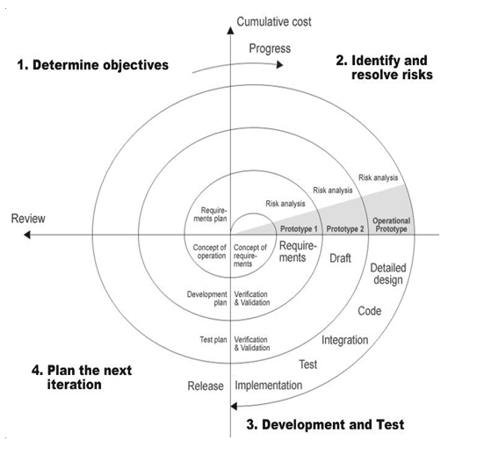

**12**

* 1. Architecture

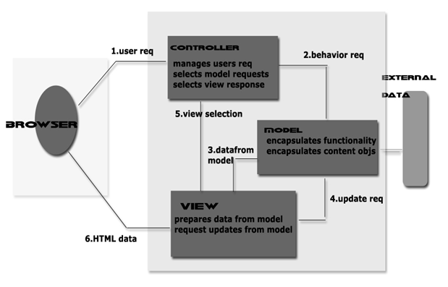

Layered Architecture

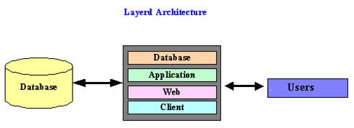

Database Layer**:** Contains the data and database-related objects like stored procedures, triggers, packages, etc.

Application Layer**:** Contains the objects addressing the business logic; Most of the middle-level Java objects will be here in application layer.

Web Interface Layer**:** It will be on the web server; It contains the web pages (JSPs) of the application which will interact with the front-end browsers

Client Layer**:** Contains the web browser which interacts with web server. **13**

* 1. UML Diagrams

4.5.1 Class Diagram

r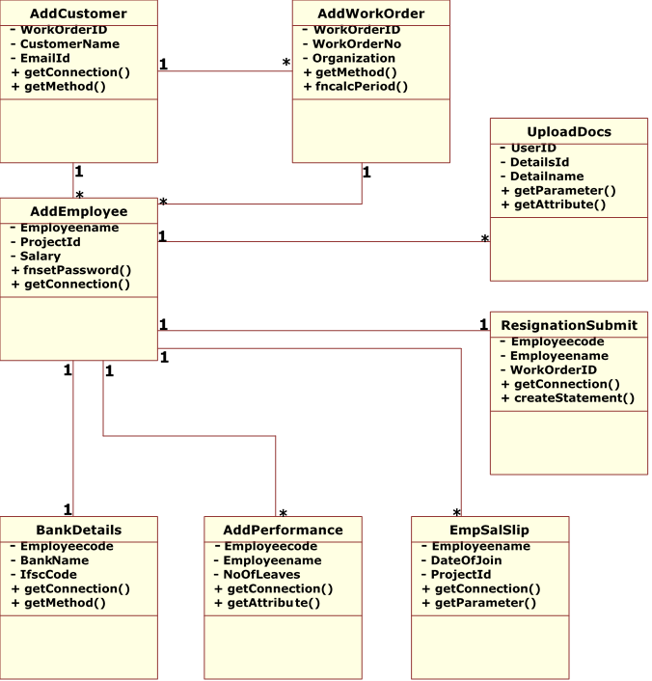

**14**

4.5.2 Use Case Diagram

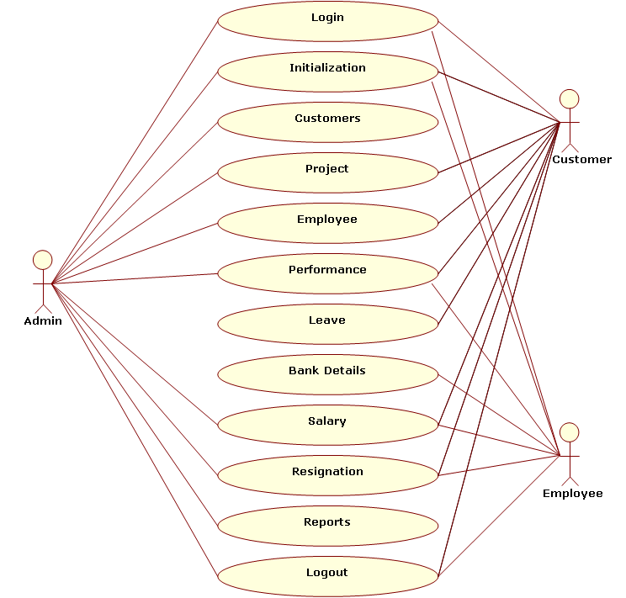

4.5.3 Activity Diagram  **15**

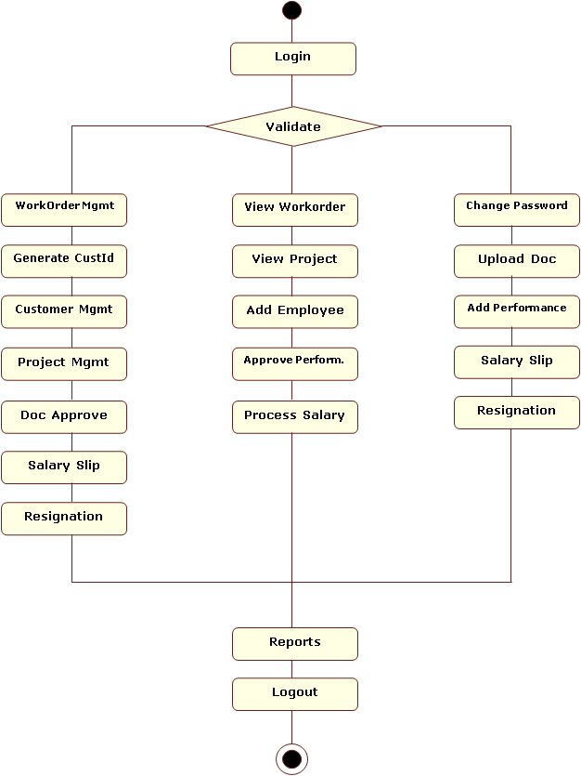

* 1. Normalization **16**

A Database is a collection of interrelated data stored with a minimum of redundancy to serve many applications. The database design is used to group data into a number of tables and minimizes the artificiality embedded in using separate files. The tables are organized to:

* Reduced duplication of data.
* Simplify functions like adding, deleting, modifying data, etc.
* Retrieving data
* Clarity and ease of use
* More information at low cost

Normalization is built around the concept of normal forms. A relation is said to be in a particular normal form if it satisfies a certain specified set of constraints on the kind of functional dependencies that could be associated with the relation. The normal forms are used to ensure that various types of anomalies and inconsistencies are not introduced into the database.

First Normal Form: A relation R is in first normal form if and only if all underlying domains contained atomic values only.

Second Normal Form: A relation R is said to be in second normal form if and only if it is in first normal form and every non-key attribute is fully dependent on the primary key.

Third Normal Form: A relation R is said to be in third normal form if and only if it is in second normal form and every non key attribute is non transitively depend on the primary key.

* 1. Data Dictionary

A Data Dictionary is a collection of metadata, that is, data about data. In addition to storing catalog information about schemas and constraints, the data dictionary stores other information, such as design decisions, usage standards, application program descriptions, and user information.

Table Name: bankdetails;

Constraint: BankID PRIMARY KEY

|  |  |  |  |
| --- | --- | --- | --- |
| Field | Type | Key | Extra |
| BankID | int(5) | PRI | auto_increment |
| Employeecode | varchar(100) |  |  |
| BankName | varchar(200) |  |  |
| BankAddress | varchar(200) |  |  |
| AccountHolderName | varchar(200) |  |  |
| AccountNo | varchar(200) |  |  |
| IfscCode | varchar(100) |  |  |

Table Name: customerinfo;

|  |  |  |  |
| --- | --- | --- | --- |
| Field | Type | Key | Extra |
| WorkOrderID | varchar(100) |  |  |
| CustomerId | varchar(100) |  |  |
| CustomerName | varchar(100) |  |  |
| CustPassword | varchar(100) |  |  |
| ContactNo | varchar(100) |  |  |
| Address | varchar(100) |  |  |
| EmailId | varchar(100) |  |  |

Table Name: documentsdesc;

|  |  |  |  |
| --- | --- | --- | --- |
| Field | Type | Key | Extra |
| DetailsId | varchar(200) |  |  |
| DocumentDesc | varchar(200) |  |  |

Table Name: employeedetails;

Constraint: Employeecode PRIMARY KEY

|  |  |  |  |
| --- | --- | --- | --- |
| Field | Type | Key | Extra |
| Employeecode | varchar(50) | PRI |  |
| Employeename | varchar(50) |  |  |
| EmployeePassword | varchar(100) |  |  |
| Gender | varchar(10) |  |  |
| Address | varchar(200) |  |  |
| PhoneNo | varchar(20) |  |  |
| EmailID | varchar(100) |  |  |
| Designation | varchar(100) |  |  |
| WorkOrderID | varchar(100) |  |  |
| ProjectId | varchar(100) |  |  |
| DateOfJoin | Datetime |  |  |
| Salary | Double |  |  |
| Status | varchar(50) |  |  |

Table Name: login;

Constraint: UserId, Auth PRIMARY KEY

|  |  |  |  |
| --- | --- | --- | --- |
| Field | Type | Key | Extra |
| UserId | varchar(25) | PRI |  |
| Password | varchar(25) |  |  |
| Auth | varchar(10) |  |  |

Table Name: monthslist;

Constraint: MonthNo, MonthName PRIMARY KEY

|  |  |  |  |
| --- | --- | --- | --- |
| Field | Type | Key | Extra |
| MonthNo | varchar(20) |  |  |
| MonthName | varchar(20) |  |  |

* 1. ER Diagram  **19**

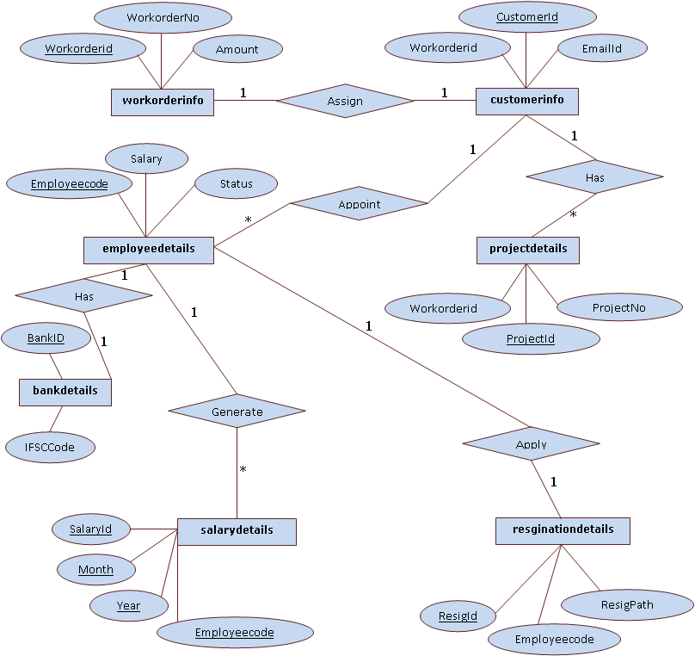

1. Technologies **20**

#### Front end or User Interface Design

#### The entire user interface is planned to be developed in browser specific environment with a touch of Intranet-Based Architecture for achieving the Distributed Concept. The browser specific components are designed by using the HTML standards, and the dynamism of the designed by concentrating on the constructs of the Java Server Pages.

#### Communication or Database Connectivity Tier

The Communication architecture is designed by concentrating on the Standards of Servlets and Enterprise Java Beans. The database connectivity is established by using the Java Data Base Connectivity. The standards of three-tier architecture are given major concentration to keep the standards of higher cohesion and limited coupling for effectiveness of the operations.

About Java:

Initially the language was called as “oak” but it was renamed as “Java” in 1995. The primary motivation of this language was the need for a platform-independent (i.e., architecture neutral) language that could be used to create software to be embedded in various consumer electronic devices.

* Java is a programmer’s language.
* Java is cohesive and consistent.
* Except for those constraints imposed by the Internet environment, Java gives the programmer, full control.

Finally, Java is to Internet programming where C was to system programming.

Importance of Java to the Internet

Java has had a profound effect on the Internet. This is because; Java expands the Universe of objects that can move about freely in Cyberspace. In a network, two categories of objects are transmitted between the Server and the Personal computer. They are: Passive information and Dynamic active programs. The Dynamic, Self-executing programs cause serious problems in the areas of Security and probability. But, Java addresses those concerns and by doing so, has opened the door to an exciting new form of program called the Applet.

Servlets

Introduction **21**

The Java web server is JavaSoft's own web Server. The Java web server is just a part of a larger framework, intended to provide you not just with a web server, but also with tools. To build customized network servers for any Internet or Intranet client/server system. Servlets are to a web server, how applets are to the browser.

About Servlets

Servlets provide a Java-based solution used to address the problems currently associated with doing server-side programming, including inextensible scripting solutions, platform-specific APIs, and incomplete interfaces.

Servlets are objects that conform to a specific interface that can be plugged into a Java-based server. Servlets are to the server-side what applets are to the client-side - object byte codes that can be dynamically loaded off the net. They differ from applets in that they are faceless objects (without graphics or a GUI component). They serve as platform independent, dynamically loadable, pluggable helper byte code objects on the server side that can be used to dynamically extend server-side functionality.

For example, an HTTP Servlets can be used to generate dynamic HTML content. When you use Servlets to do dynamic content you get the following advantages:

* They’re faster and cleaner than CGI scripts
* They use a standard API (the Servlets API)
* They provide all the advantages of Java (run on a variety of servers without needing to be rewritten).

Attractiveness of Servlets

There are many features of Servlets that make them easy and attractive to use. These include:

* Easily configured using the GUI-based Admin tool
* Can be [loaded and invoked](load.html) from a local disk or remotely across the network.
* Can be linked together, or [chained](filter.html), so that one Servlets can call another Servlets, or several Servlets in sequence.
* Can be called dynamically from within HTML pages, using [server-side include](ssinclude.html) tags.
* Are secure - even when downloading across the network, the Servlets security model and Servlets sandbox protect your system from unfriendly behavior.

Java Script

JavaScript is a script-based programming language that was developed by Netscape Communication Corporation. JavaScript was originally called Live Script and renamed as JavaScript to indicate its relationship with Java. JavaScript supports the development of both

**22**

client and server components of Web-based applications. On the client side, it can be used to write programs that are executed by a Web browser within the context of a Web page. On the server side, it can be used to write Web server programs that can process information submitted by a Web browser and then updates the browser’s display accordingly

Even though JavaScript supports both client and server Web programming, we prefer JavaScript at Client side programming since most of the browsers supports it. JavaScript is almost as easy to learn as HTML, and JavaScript statements can be included in HTML documents by enclosing the statements between a pair of scripting tags. <SCRIPTS>.

</SCRIPT>.

<SCRIPT LANGUAGE = “JavaScript”>

JavaScript statements

</SCRIPT>

Here are a few things we can do with JavaScript:

* Validate the contents of a form and make calculations.
* Add scrolling or changing messages to the Browser’s status line.
* Animate images or rotate images that change when we move the mouse over them.
* Detect the browser in use and display different content for different browsers.
* Detect installed plug-ins and notify the user if a plug-in is required.
* We can do much more with JavaScript, including creating entire application.

Hyper Text Markup Language

Hypertext Markup Language (HTML), the languages of the World Wide Web (WWW), allows users to produces Web pages that include text, graphics and pointer to other Web pages (Hyperlinks).

HTML is not a programming language but it is an application of ISO Standard 8879, SGML (Standard Generalized Markup Language), but specialized to hypertext and adapted to the Web. The idea behind Hypertext is that instead of reading text in rigid linear structure, we can easily jump from one point to another point. We can navigate through the information based on our interest and preference. A markup language is simply a series of elements, each delimited with special characters that define how text or other items enclosed within the elements should be displayed. Hyperlinks are underlined or emphasized works that load to other documents or some portions of the same document.

**23**

HTML can be used to display any type of document on the host computer, which can be geographically at a different location. It is a versatile language and can be used on any platform or desktop. HTML provides tags (special codes) to make the document look attractive. HTML tags are not case-sensitive. Using graphics, fonts, different sizes, color, etc., can enhance the presentation of the document. Anything that is not a tag is part of the document itself.

Basic HTML Tags:

**<! -- -->** Specifies comments

**<A>………. </A>** Creates hypertext links

**<B>………. </B>** Formats text as bold

**<BIG>………. </BIG>** Formats text in large font.

**<BODY>…</BODY>** Contains all tags and text in the HTML document

**<CENTER>...</CENTER>** Creates text

**<DD>…</DD>** Definition of a term

**<DL>...</DL>**  Creates definition list

**<FONT>…</FONT>** Formats text with a particular font

**<FORM>...</FORM>** Encloses a fill-out form

**<FRAME>...</FRAME>** Defines a particular frame in a set of frames

**<H#>…</H#>** Creates headings of different levels

**<HEAD>...</HEAD>** Contains tags that specify information about a document

**<HR>...</HR>** Creates a horizontal rule

**<HTML>…</HTML>** Contains all other HTML tags

**<META>...</META>** Provides meta-information about a document

**<SCRIPT>…</SCRIPT>** Contains client-side or server-side script

**<TABLE>…</TABLE>**  Creates a table

**<TD>…</TD>** Indicates table data in a table

**<TR>…</TR>** Designates a table row

**<TH>…</TH>** Creates a heading in a table

Java Database Connectivity **24**

What Is JDBC?

JDBC is a Java API for executing SQL statements. (As a point of interest, JDBC is a trademarked name and is not an acronym; nevertheless, JDBC is often thought of as standing for Java Database Connectivity. It consists of a set of classes and interfaces written in the Java programming language. JDBC provides a standard API for tool/database developers and makes it possible to write database applications using a pure Java API.

Using JDBC, it is easy to send SQL statements to virtually any relational database. One can write a single program using the JDBC API, and the program will be able to send SQL statements to the appropriate database. The combinations of Java and JDBC lets a programmer write it once and run it anywhere.

What Does JDBC Do?

Simply put, JDBC makes it possible to do three things:

* Establish a connection with a database
* Send SQL statements
* Process the results.

JDBC versus ODBC and other APIs

At this point, Microsoft's ODBC (Open Database Connectivity) API is that probably the most widely used programming interface for accessing relational databases. It offers the ability to connect to almost all databases on almost all platforms.

So why not just use ODBC from Java? The answer is that you can use ODBC from Java, but this is best done with the help of JDBC in the form of the JDBC-ODBC Bridge, which we will cover shortly. The question now becomes "Why do you need JDBC?" There are several answers to this question:

* ODBC is not appropriate for direct use from Java because it uses a C interface. Calls from Java to native C code have a number of drawbacks in the security, implementation, robustness, and automatic portability of applications.
* A literal translation of the ODBC C API into a Java API would not be desirable. For example, Java has no pointers, and ODBC makes copious use of them, including the notoriously error-prone generic pointer "void *". You can think of JDBC as ODBC translated into an object-oriented interface that is natural for Java programmers.
* ODBC is hard to learn. It mixes simple and advanced features together, and it has complex options even for simple queries. JDBC, on the other hand, was designed to keep simple things simple while allowing more advanced capabilities where required.

**25**

* A Java API like JDBC is needed in order to enable a "pure Java" solution. When ODBC is used, the ODBC driver manager and drivers must be manually installed on every client machine. When the JDBC driver is written completely in Java, however, JDBC code is automatically installable, portable, and secure on all Java platforms from network computers to mainframes.

Java Server Pages (JSP)

Java server Pages is a simple, yet powerful technology for creating and maintaining dynamic-content web pages. Based on the Java programming language, Java Server Pages offers proven portability, open standards, and a mature re-usable component model. The Java Server Pages architecture enables the separation of content generation from content presentation. This separation not eases maintenance headaches; it also allows web team members to focus on their areas of expertise. Now, web page designer can concentrate on layout, and web application designers on programming, with minimal concern about impacting each other’s work.

Features of JSP

* Portabilit**y:**Java Server Pages files can be run on any web server or web-enabled application server that provides support for them. Dubbed the JSP engine, this support involves recognition, translation, and management of the Java Server Page lifecycle and its interaction components.
* Components:It was mentioned earlier that the Java Server Pages architecture can include reusable Java components. The architecture also allows for the embedding of a scripting language directly into the Java Server Pages file. The components current supported include Java Beans, and Servlets.
* Processing:A Java Server Pages file is essentially an HTML document with JSP scripting or tags. The Java Server Pages file has a JSP extension to the server as a Java Server Pages file. Before the page is served, the Java Server Pages syntax is parsed and processed into a Servlet on the server side. The Servlet that is generated outputs real content in straight HTML for responding to the client.
* Access Models***:*** A Java Server Pages file may be accessed in at least two different ways. A client’s request comes directly into a Java Server Page. In this scenario, suppose the page accesses reusable Java Bean components that perform particular well-defined computations like accessing a database. The result of the Beans computations, called result sets is stored within the Bean as properties. The page uses such Beans to generate dynamic content and present it back to the client.

**26**

In both of the above cases, the page could also contain any valid Java code. Java Server Pages architecture encourages separation of content from presentation.

Steps in the execution of a JSP Application***:***

* The client sends a request to the web server for a JSP file by giving the name of the JSP file within the form tag of a HTML page.
* This request is transferred to the JavaWebServer. At the server side JavaWebServer receives the request and if it is a request for a JSP file server gives this request to the JSP engine.
* JSP engine is program which can understands the tags of the jsp and then it converts those tags into a Servlet program and it is stored at the server side. This Servlet is loaded in the memory and then it is executed and the result is given back to the JavaWebServer and then it is transferred back to the result is given back to the JavaWebServer and then it is transferred back to the client.

JDBC connectivity

The JDBC provides database-independent connectivity between the J2EE platform and a wide range of tabular data sources. JDBC technology allows an Application Component Provider to:

* Perform connection and authentication to a database server
* Manager transactions
* Move SQL statements to a database engine for preprocessing and execution
* Execute stored procedures
* Inspect and modify the results from Select statements.

1. Testing

Testing is the process of detecting errors. Testing performs a very critical role for quality assurance and for ensuring the reliability of software. The results of testing are used later on during maintenance also.

Testing Objectives:

The main objective of testing is to uncover a host of errors, systematically and with minimum effort and time. Stating formally, we can say,

* Testing is a process of executing a program with the intent of finding an error.
* A successful test is one that uncovers an as yet undiscovered error.
* A good test case is one that has a high probability of finding error, if it exists.
* The tests are inadequate to detect possibly present errors.
* The software more or less confirms to the quality and reliable standards. **27**

Client Needs Acceptance Testing

Requirements System Testing

Design Integration Testing

Code Unit Testing

Levels of Testing

In order to uncover the errors, present in different phases we have the concept of levels of testing. The basic levels of testing are

Unit testing:

Unit testing focuses verification effort on the smallest unit of software i.e. the module. Using the detailed design and the process specifications testing is done to uncover errors within the boundary of the module. All modules must be successful in the unit test before the start of the integration testing begins.

In this project each service can be thought of a module. There are so many modules like Admin, Tracking, and Inventory. Each module has been tested by giving different sets of inputs. When developing the module as well as finishing the development so that each module works without any error. The inputs are validated when accepting from the user.

Integration Testing:

After the unit testing we have to perform integration testing. The goal here is to see if modules can be integrated properly, the emphasis being on testing interfaces between modules. This testing activity can be considered as testing the design and hence the emphasis on testing module interactions.

In this project the main system is formed by integrating all the modules. When integrating all the modules I have checked whether the integration effects working of any of the services by giving different combinations of inputs with which the two services run perfectly before Integration.

System Testing: **28**

Here the entire software system is tested. The reference document for this process is the requirements document, and the goal is to see if software meets its requirements. Here entire ‘COMS’ has been tested against requirements of project and it is checked whether all requirements of project have been satisfied or not.

Acceptance Testing:

Acceptance Test is performed with realistic data of the client to demonstrate that the software is working satisfactorily. Testing here is focused on external behavior of the system; the internal logic of program is not emphasized.

In this project **‘Consulting & Outsourcing Management Software’** I have collected some data and tested whether project is working correctly or not. Test cases should be selected so that the largest number of attributes of an equivalence class is exercised at once. The testing phase is an important part of software development. It is the process of finding errors and missing operations and also a complete verification to determine whether the objectives are met and the user requirements are satisfied.

6.1 Test Cases Table

Test Case Report

|  |  |  |  |  |  |
| --- | --- | --- | --- | --- | --- |
| **S.NO** | **TESTING OBJECT** | **EXPECTED VALUE** | **SIMULATED VALUE** | **EXPLANATION** | **REMARKS** |
| 1 | Login/UserID | “name” | “name” | Pass | Expected Value=Simulated Value |
| 2 | Login/UserID | “name” | “” | Fail | User ID  Field  empty |
| 3 | Login/UserID | “name” | “NAME” | Fail | Case Sensitive |
| 4 | Login/Password | “password” | “password” | Pass | Expected Value=Simulated Value |
| 5 | Login/Password | “password” | “” | Fail | Password  Field  Empty |
| 6 | Login/Password | “password” | “PASSWORD” | Fail | Case Sensitive |

1. Conclusion **29**

The “**Consulting & Outsourcing Management Software”** is web-based applications. This application software has been computed successfully and was also tested successfully by taking “test cases”. It is user friendly, and has required options, which can be utilized by the user to perform the desired operations.

The software is developed using Java as front end and MySQL as back end in Windows environment. The goals that are achieved by the software are:

* Instant access.
* Improved productivity.
* Optimum utilization of resources.
* Efficient management of records.
* Simplification of the operations.
* Less processing time and getting required information.
* User friendly.

1. Limitations and Future Enhancements

Limitations:

* It is only the intranet application. Because of this if any employee is working from client place then he can’t enter into this application from online since it’s access is restrict within the company.
* Documents should be processed by the customer first then admin. But here two level checking is not done.
* The project flow is little bit clumsy which should be simplified.
* Most of the time the database server is busy by providing authentication.

Future Enhancements:

* Extendibility: Provides high level extendibility. It means it provides all the basic features and allows us to extend their features very easily without disturbing the existing code.
* We can make this application is suitable to work on any application just by changing the deployment files.
* By providing some more features like providing accessibility to internet for branch office.